Architecture Breakdown: Selenium, Cypress, and Playwright
1. Selenium WebDriver
- Components: Client libraries, W3C protocol, browser drivers (e.g., chromedriver.exe), browsers.
- Workflow: Test scripts → HTTP requests → browser drivers → browsers → responses back to scripts.
- Strengths:
  - Supports multiple programming languages.
  - Broad browser compatibility.
  - Good for complex, large-scale projects.
- Use Cases: Google search automation, LinkedIn platform testing.
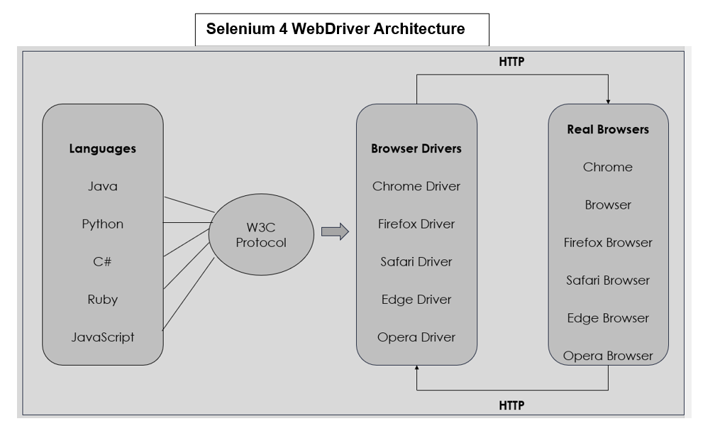

2. Playwright
- Components: Language bindings, WebSocket protocol, browser contexts.
- Workflow: Persistent WebSocket connection allows faster, continuous communication between client and server.
- Strengths:
  - Fast execution.
  - Parallel testing via browser contexts.
  - Cross-platform and cross-browser support.
- Use Cases: Modern apps needing speed and reliability (e.g., trading apps, gaming, Slack, GitHub).
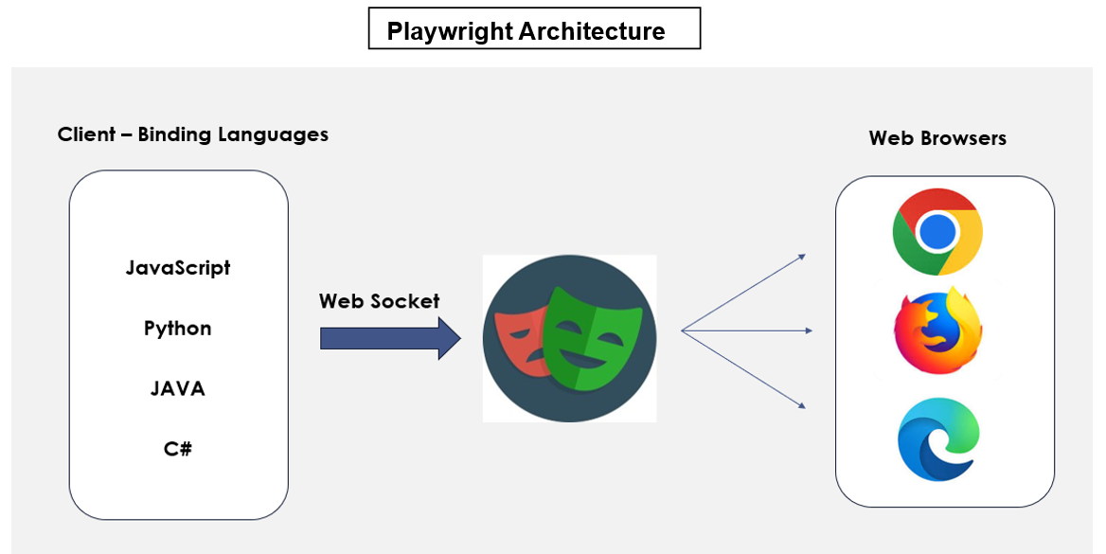

3. Cypress
- Components: Node.js runtime, built-in proxy server, test runner, actual browser.
- Workflow: Runs directly inside the browser with two iframes (one for Cypress, one for the app). Direct DOM and network access.
- Strengths:
  - Real-time debugging and screenshots.
  - Automatic waits and live reloads.
  - Developer-friendly, fast feedback loops.
- Use Cases: Front-end testing, rapid development cycles (e.g., Pactflow, Gatsby).
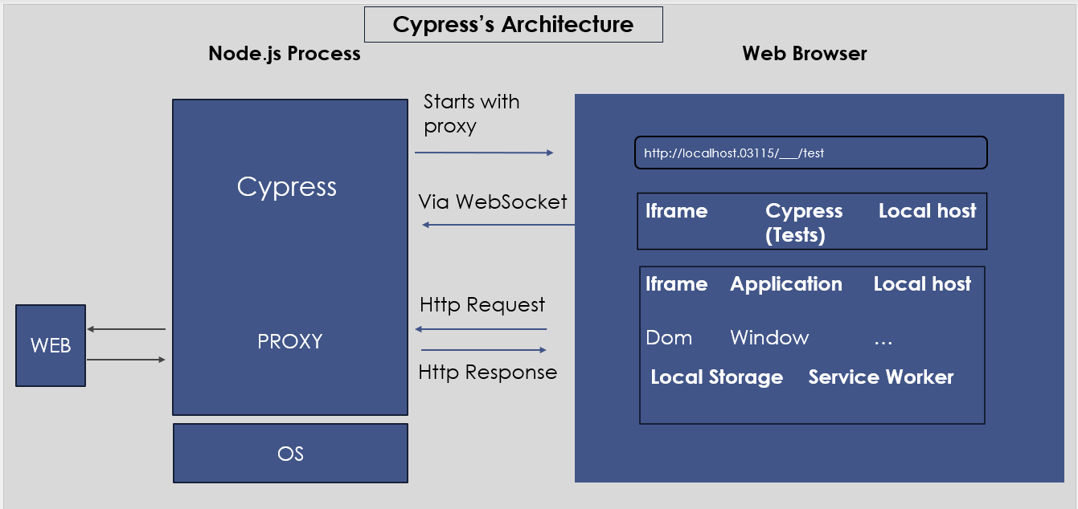

Comparative Insights
Feature | Selenium WebDriver | Playwright | Cypress
Protocol | HTTP (W3C) | WebSocket | Runs inside browser
Language Support | Many (Java, Python, etc.) | Many (JS, TS, Python, etc.) | JavaScript only
Parallel Execution | Limited | Strong via browser contexts | Limited
Speed | Moderate | High | High (for front-end)
Best Fit | Complex, multi-language projects | Modern, fast, multi-context apps | Rapid front-end testing

